Tribal Public Health Law:
WESTERN AREA

OVERVIEW

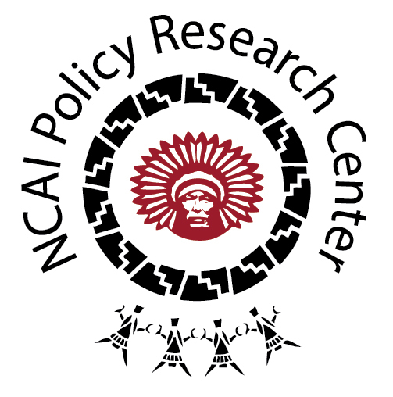
NCAI’s Western Area includes tribes in Arizona, Nevada, and Utah. Tribal nations from the Western Area that have given NCAI permission to share their codes through the database include the Ely Shoshone Tribe and the Tohono O’odham Nation. For full access to codes from the Northwest region for which we have tribal consent to publicly share, please visit our new online Tribal Public Health Law Database at http://www.ncai.org/policy-research-center/initiatives/projects/tribal-public-health-law.

KEY THEMES

There are two major trends to note in the codes from the Western Area, including:

- Water is a precious and increasingly scarce resource in the region. Both tribes have codes related to water conservation and water quality reflecting the importance tribal governments in the Western Region place on water. Ely Shoshone’s Outside Water Restrictions policy includes citation provisions for waste of water.

- Both tribes have established codes and policies with particular emphasis on protection children. Tohono O’odham has a Children’s Code (Title 3) that includes provisions aimed at promoting child health and wellness, and Ely Shoshone has set out a range of “Crimes Against Public Health and Safety” (Chapter 202) that include regulations specific to child health (e.g., limits on leaving children unattended in motor vehicles; mandatory reporting of offenses against children; and regulations against the sale of commercial tobacco and firearms to juveniles).
SAMPLE CODES

- Drug-Related Codes. It is clear that the Ely Shoshone Tribe has had to address various issues related to drug use in its community. The Tribe has taken a unique approach to regulating medical marijuana and allowing for the cleanup of contamination from the manufacture of illegal drugs, such as methamphetamine.

- Emergency Planning and Community “Right to Know” Policy. The Tohono O’odham Nation’s Title 15, Chapter 7, “Emergency Planning and Community Right-to-Know” Ordinance, sets out provisions to address and inform the public as to emergencies involving hazardous materials and natural disasters.

- Boxing and Unarmed Combat Policy. In order to address a growing trend in many tribal communities shaped by the increased interest in sports like mixed martial arts (MMA), The Tohono O’odham Nation has established a Boxing and Unarmed Conflict Ordinance (Title 17, Chapter 5) that establishes a Commission to oversee boxing and unarmed conflict and set out other provision to ensure the safety of citizens engaging in these activities.

- Archaeological Resources Protection Ordinance. The Tohono O’odham Nation sets out provisions to protect “any material remains of past human life or activities which are of archaeological interest and the physical site, location or context in which they are found” (Ordinance Number 06-84). This effort is framed as important for the protection of the Nation’s health and constitutes a unique conception of public health.

