Tribal Public Health Law:
MIDWEST AREA

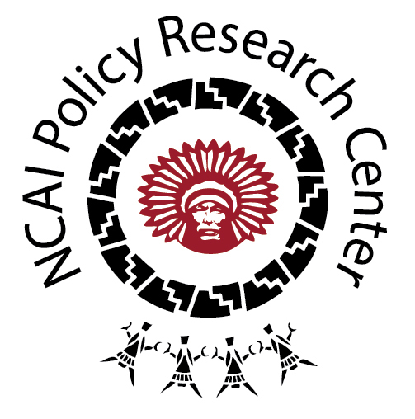

OVERVIEW

NCAI’s Midwest Area includes tribes in Illinois, Iowa, Minnesota, and Wisconsin. It is the Area that has the highest number of tribal public health codes in the NCAI database. Tribal nations from the Midwest Area that have given NCAI permission to share their codes through the database include: Bay Mills Indian Community of Michigan; Grand Travers Band of Ottawa and Chippewa Indians; Ho-Chunk Nation; Leech Lake Band of Ojibwe; Little Traverse Bay Bands of Odawa Indians; Fond du Lac Band of Lake Superior Chippewa; Red Cliff Band of Lake Superior Chippewa Indians; Red Lake Band of Chippewa Indians; and the Nottawaseppi Huron Band of the Potawatomi Indians. For full access to codes from the Midwest Area for which we have tribal consent to publicly share, please visit our new online Tribal Public Health Law Database at http://www.ncai.org/policy-research-center/initiatives/projects/tribal-public-health-law.

KEY THEMES

There are a few trends to note in the codes from the Midwest Area, including:

- Ensuring public health through tribal code and policy is often framed as promoting public safety. For instance, there are a range of codes aimed at diminishing hazardous conditions (e.g., regulating firearm use and possession, preventing injury from fireworks; limiting open burning); preventing harm done by animals; ensuring that tribal organizations and businesses operate in a safe manner (e.g., waste water treatment provisions); and promoting safe use of snowmobiles and fishing vessels to prevent injury in off-road transportation.

- There are several codes related to fair and safe labor practice and the regulation of tribal business activity (e.g., food services, hotel businesses, and priority for purchasing recyclables), emphasizing the responsibilities tribal governments have to foster public health amongst tribal employees and through tribal businesses. This trend may reflect the large number of tribal enterprise in the region. One of the most unique is the Fond du Lac Band of Lake Superior Chippewa’s Electrofishing Safety Code (Ordinance #07/94).

- Due in large part to the significance of traditional foods like wild rice in the region, there are several codes related to protecting cultural foods and resources. For example, the Leech Lake Band of Ojibwe have a policy designed to limit “Wild Rice Genetic Research and Patenting”; the Fond du Lac Band of Lake Superior Chippewa have a similar policy entitled, “Prohibition of Genetic Modification of Mahnomen”; and the Ho-Chunk Nation has established a Research Code that includes oversight of research on tribal lands for which the Nation has jurisdiction and using materials that the Nation claims ownership, which could include traditional foods.

SAMPLE CODES

- Breastfeeding Code. Chapter 8 of the Title XI Health and Education Code of the Little Traverse Bay Band of Odawa Indians emphasizes the right to breastfeed. Called “Right to Breastfeed and Civil Offense for Discrimination”, this code promotes breastfeeding of children because breast milk “provides a better nutrition and higher immunity against diseases, is better to digest, and may increase the children’s IQ.” It established breastfeeding discrimination as a civil offense and empower law officers to issue a notice of violation citation.

- Food-Related Policies:

  - Key Provisions of a Tribal Food Safety Act. Chapter 6 of the Title XI Health and Education Code of the Little Traverse Bay Band of Odawa Indians details where the Tribe’s regulatory authority is based (e.g., in the business code); includes provisions for the Tribe to inspect food service, preparation, and sales facilities; and provides for a fee schedule for permitting to help cover costs of regulation and inspection (between $10 and $100 based on the type of facility – temporary/permanent with lower fees for Head Start, schools, and non-profit corporations). Includes special provisions prevent burdens on food-related businesses operated in tribal homes and calls for temperatures and time requirements to be detailed in pamphlet format.

  - Preventing Genetic Modification of Traditional Foods. As stated earlier, both Leech Lake and Fond du Lac have codes designed to protect traditional foods.

  - Fish Consumption Guidance. The Leech Lake Band of Ojibwe has developed a policy designed to protect their citizens by providing information related to the mercury and other pollutant content of locally sourced fish and guidance about safe consumption.

- Tribal-State Relations. There are a range of ways, even within a particular tribal nation, that state law is referenced and used to enforce tribal public health law such as in Ho-Chunk law:

  - “Where a provision of this Ordinance correlates with Wisconsin Statutes or with a standard in Wisconsin Administrative Code, and where the Ordinance provision is unclear, the provision shall be interpreted in light of the current Wisconsin law in effect, as long as consistent with Ho-Chunk Nation law.”

  - “If tribal law, customs and traditions are inconclusive in any matter arising under this Act, then federal law and, as a last resort, the law of the State of Wisconsin may be used for guidance.”

- Public Nuisance as a Framework for Categorizing Threats to Public Health. The Ho-Chunk Nation categorizes several violations as public nuisances that may also be understood as threats to public health, including those related to: disorderly houses, dilapidated buildings,
vehicle abandonment, nuisances created by animas, and drug or criminal “gang-houses”. The Tribe designates a Sanitarian who can inspect properties to determine if there are health hazards or threats to public safety. There are extensive provisions for how to ensure the violations are abated and penalties described. Further, Bay Mills Indian Community of Michigan enforces public nuisance provisions through imprisonment, fines, and/or removal from the community.

- Requirements for Tribal Businesses and Departments. While efforts by tribal governments to require recycling and the purchase of recycled products by tribal businesses may not seem like a public health law, this code reflects the importance of government decision-making that prioritizes environmental sustainability by reducing waste and the need for more waste management (Ho-Chunk, Title 3, Section 1; Red Cliff, Chapter 38). In addition, the Fond du Lac Band of Lake Superior Chippewa has a policy entitled, “Establishing Standards for Fats, Oils, and Grease Reduction” to prevent tribal businesses and other entities from releasing harmful fats, oils, and grease into the Band’s wastewater conveyance system .

- Enforcement Parameters include Permitting, Fining, Civil & Criminal Action, and Exclusion. The Ho-Chunk Nation has a policy (Title 3, Section 10) that defines parameters for exclusion and removal of persons who do not abide by tribal code.

- Domestic Violence As a Public Health Issue. The Ho-Chunk Nation has a Domestic Abuse Act (Title 4, Section 5), which includes a provision to prevent employers from terminating employees who have missed work due to domestic abuse proceedings; protections for advocates and community officers; and a call to establish a domestic abuse prevention plan.

