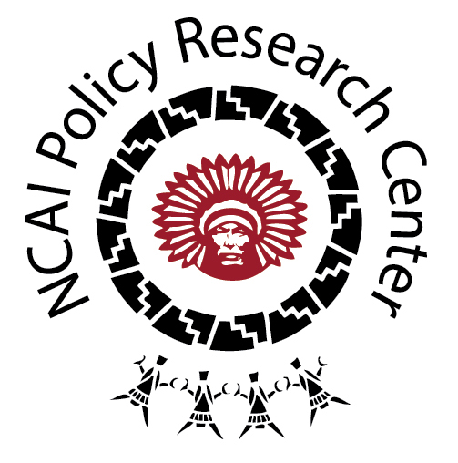
Tribal Public Health Law:
Alcohol, Tobacco, & Other Drugs

OVERVIEW

Of the 12 categories used to organize the tribal codes and policies included in the Tribal Public Health Law Database, Alcohol, Tobacco, and Substance Control is the fourth largest category, representing approximately 11 percent of the codes collected from the public domain. Approaching this category requires some nuance—in particular, an understanding that the regulation of tobacco often depends on whether its use is for cultural or commercial purposes. In its traditional use, tobacco is medicine; it is an important part of ceremony, as an offering or smoked from pipes so as to carry one’s prayers to the heavens or seal a compact between groups or persons. Contemporary misuse of tobacco, however, is largely connected to the commodification of cigarettes. As a whole, the American Indian/Alaska Native (AI/AN) population ranks high for its tobacco use; yet progress with public health interventions and the passage of tribal codes has helped curb this trend, with cigarette use decreasing from 32 percent in 2005 to 21.8 percent in 2012. With respect to alcohol and illicit drug use, however, much work remains for tribal governments and public health practitioners. In 2013, the rate of substance dependence or abuse was 14.9 percent for AI/ANs aged 12 or older, as compared with 8.6 percent for Hispanics, 8.4 percent for Whites, 7.4 percent for African Americans, and 4.6 percent among Asians. The codes in this memo reflect a diversity of tribal responses to public health concerns and pose questions to the broader field.

DESCRIBING THE CATEGORY

This category is rather straightforward in its composition, primarily being comprised of liquor ordinances, tobacco codes, and regulations against illicit drug use. Perhaps the primary deviation from the norm is found in housing codes, where tribes are addressing the manufacture of illicit substances and the impact this has on the health and safety of future inhabitants of the home or property contaminated by the toxic chemicals. It should also be noted that tribes vary greatly in their approaches to the control of drugs, tobacco, and alcohol. Some tribal nations have instituted “dry rez” bans on alcohol, others allow it only in their gaming facilities, and still others regulate every liquor transaction. Similarly, tobacco is afforded varying degrees of permission on tribal lands—for some tribes its sale constitutes an important revenue generator. Overall, however, there appears to be consensus around the preservation of its ceremonial use.

TRIBAL EXAMPLES

- The Nez Perce Tribe of Idaho has implemented a code that highly regulates the sale of alcohol and tobacco on tribal land. Cigarettes and liquor for sale in licensed outlets must be stamped for proof of payment of the tribal excise tax. Upon each transaction, the customer fills in their contact information so as to ensure a full record of sales. Retailer sales reports must be filed to the Nez Perce Tribe on the 15th of each month.

- The Nottawaseppi Huron Band of the Potawatomi Indians enacted a tobacco code “to ensure that all tribal members, family, friends, employees and tribal guests, and the next seven generations are not exposed to commercial tobacco use.” It specifically reserves the right to ceremonial and/or traditional tobacco use, which includes “carrying tobacco ties, passing a traditional pipe, wearing a tobacco pouch, or possessing a single cigarette to be immediately used in a traditional manner (i.e. to ask for a blessing or a favor of someone). To eliminate tobacco’s visual representations on tribal land, the code requires the removal of all tobacco advertisements—tribal employees may not “wear clothing or other items that bear tobacco company brand logos at schools or other community events during work hours.” The code prohibits smoking in all tribal buildings, with the exception of designated areas in gaming facilities, which also allow smokeless tobacco (e-cigarettes).

- In response the illegal manufacturing of drugs in homes on the reservation, the Ely Shoshone Tribe passed a code mandating the cleanup of toxic chemicals that “endanger the life, safety or welfare of the general public or any occupants of the property.” The code reflects a great deal of interagency cooperation in carrying out the decontamination—between the Tribal council, state health officer, state fire marshal, director of poison control, public health agencies, and state and federal environmental agencies.

- According to a code passed in 1980 by the Sisseton-Wahpeton Oyate, “alcoholism and drug abuse are major health and social problem afflicting an alarmingly high percentage of the members of the Tribe...costing the Tribe great human suffering in death injuries, suicide, sickness, crime, domestic violence, child abuse, neglect…” In response to these observations, the Tribe approached alcoholism and drug abuse as illnesses and has worked to ensure community support for treatment and rehabilitation.

- Formerly, and somewhat similarly to the previous tobacco code, the Eastern Band of Cherokee Indians had implemented a “pseudo-dry” reservation policy, where alcohol could only be sold at the casino. A Tribal Alcoholic Beverage Control Commission was established and the code noted that in emergencies, the Principal Chief could suspend the sale and transport of alcohol.

- In the Northwest region, the tension between concerns for health and economic sustainability in the sale of tobacco products is evident in the tribal codes. Swinomish tribal code recognizes “the use of tobacco products within the Reservation and by minors has the potential to harm the health of the Tribe,” but this is balanced by the reality that the “collection of tax revenues are necessary for essential government services.” As Swinomish Chairman Brian Cladoosby shared in a 2007 interview with The Seattle Times,

“Economic development has been particularly challenging in Indian Country…Because tribal land is held in trust by the federal government, it can’t be mortgaged to raise capital…”

And as a representative from the Squaxin Island Tribe furthered, “We don’t want to create a single new smoker. But we absolutely want to steal customers from [Philip Morris and RJ Reynolds]; we have no guilt about that. Who better than a government that puts the money into child care and police to do this? This isn’t a private, for-profit operation, it’s a government operation.”

- The Leech Lake Band of Ojibwe passed a “Social Host Ordinance” in response to underage alcohol consumption at tribal, private, or public gatherings and in the interest of protecting youth and the general public “from injuries related to alcohol consumption, such as alcohol overdose or alcohol-related traffic collisions.” The code identifies alcohol as “an addictive drug” and acknowledges incidents where parents have condoned underage drinking—even “providing the alcohol.” To remedy these threats to tribal public health, the code holds all social hosts of parties/events civilly responsible for the prevention of underage alcohol consumption.

- To ensure that the “Hoopa Valley Indian Reservation and the operations of tribal government are free of the destructive effects of the improper and illicit use of alcohol and drugs,” the Tribe passed a code mandating drug-free workplaces. A Fit for Duty Officer is empowered to enforce the policies, which include drug and alcohol screenings and training on the “consequences of drug and alcohol use on personal health, safety, and the work environment” as well as “behavioral clues indicative of…use and abuse.” Refresher trainings occur every 36 months.

NOTES FOR THE FIELD

- Tribes recognize the public health threat of tobacco use, but this is balanced by both cultural and economic considerations.

- Several of the codes reviewed were geared towards the prevention of the consumption of alcohol by minors, given that, in the words of the Leech Lake Band of Ojibwe Judicial Code:

“Alcohol abuse is linked to numerous health issues for our youth, including sexual assault, unprotected sexual activity, teenage pregnancy, sexually transmitted infections, physical assault and academic difficulties.”

Centers for Disease Control and Prevention (2014). Current Cigarette Smoking Among Adults—United States, 2005-2012. Morbidity and Mortality Weekly Report 63 (02): 29-34.
Substance Abuse and Mental Health Administration (2014). Results from the 2013 National Survey on Drug Use and Health: Summary of National Findings. Report accessed online at: http://www.samhsa.gov/data/NSDUH/ 2013SummNatFindDetTables/Index.aspx.
Mapes, L. V. (May 14, 2007). “Tribe to expand cigarette venture, but at what cost?” The Seattle Times. Article accessed online at: http://seattletimes.com/html/localnews/2003705950_smoking14m.html.

