Agenda
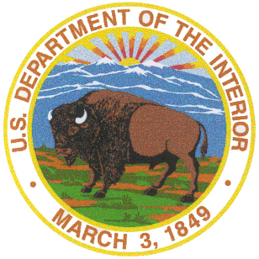
Tribal/Interior Budget Council
March 22-23, 2016
Omni Shoreham Hotel
2500 Calvert Street NW
Washington, DC 20008

Tuesday, March 22

8:30-12:00 Tribal Caucus

12:00-1:30 Lunch (on your own)

1:30-2:00 Call to Order/Roll call Larry Roberts, Acting Assistant Secretary
Ron Allen/Sam Thomas, Tribal Co-Chairs
Opening Prayer Tribal Member-TBA
Approval of Agenda Larry Roberts /Ron Allen/Sam Thomas
Approval of Minutes Larry Roberts /Ron Allen/Sam Thomas

1:30-2:00 2:00-2:30 Opening Remarks Larry Roberts/Ron Allen/Sam Thomas
2:
2:30-3:00 Road Maintenance Budget Proposal Harold Frazier, Chairman Cheyenne River Sioux
Leroy Gishi, Office of Indian Services

3:00-3:30 U.S. Census Bureau John H. Thompson, Director

3:30-4:00 Report from Tribal Caucus Ron Allen/Sam Thomas, Tribal Co-Chairs

4:00-4:30 Update from DOI Olivia Ferriter, Deputy Assistant Secretary

4:30-5:00 OST Update-2017 Budget Deb DuMontier, Deputy Special Trustee

5:00 Adjourn for the day

Wednesday, March 23

8:30-9:00 Opening Remarks Larry Roberts /Ron Allen/Sam Thomas
9:05-9:20 Eastern Oklahoma Presentation
9:25-9:40 Midwest Presentation
9:45-10:00 Eastern Presentation
10:00-10:15 Break
10:15-10:30 Southern Plains Presentation
Presentation Guidelines:
- Time is limited – no more than 15 min.
- Focus on top five FY 2018 priorities.
- Present accomplishments and needs.

10:35-10:50 Great Plains Presentation
10:55-11:10 Navajo Presentation
11:15-11:30 Alaska Presentation
11:30-1:00 Lunch (on your own)
1:00-1:15 Western Presentation
1:20-1:35 Southwest Presentation
1:40-1:55 Northwest Presentation
2:00-2:15 Pacific Presentation
2:20-2:35 Rocky Mountain Presentation
2:35-2:50 Break
2:50-3:15 Reviving the BIE Subgroup Larry Roberts, Acting Assistant Secretary

3:15-4:15 Discussion of results and strategies for 2017 Ron Allen/SamThomas

4:15-4:45 Old Business Amber Ebarb, NCAI
New Business Larry Roberts /R.Allen/S.Thomas
Agenda items for May meeting
Review dates of future TIBC meetings

4:45 Adjourn

